**Assignment 3**

// Task 1

file.open("example.txt", ios::in);

if(!file)

{

cout<<"Error: File not found"<<endl;

}

else

{

cout<<"File opened successfully"<<endl;

while(getline(file, line))

{

cout<<line<<endl;

}

}

file.close();

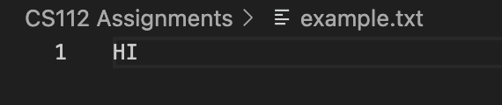



// Task 2

file.open("output.txt", ios::out);

if(!file)

{

cout<<"Error: File not found"<<endl;

}

else

{

cout<<"Enter text to write to the file: (overwrite) "<<endl;

getline(cin, line);

file<<line;

}

file.close();



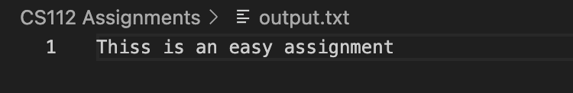

// Task 3

file.open("log.txt", ios::app);

if(!file)

{

cout<<"Error: File not found"<<endl;

}

else

{

cout<<"Enter text to write to the file: (append) "<<endl;

getline(cin, line);

file<<"\n"<<line;

}

file.close();



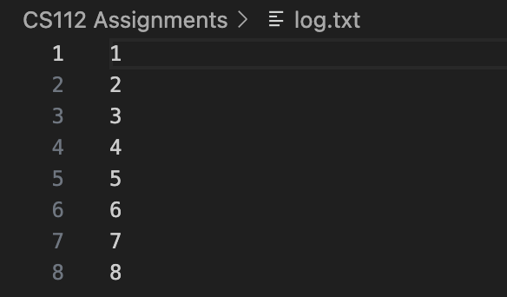

// Task 4

file.open("truncate.txt", ios::in);

if(!file)

{

cout<<"Error: File not found"<<endl;

}

else

{

cout<<"File opened successfully before truncating: "<<endl;

while(getline(file, line))

{

cout<<line<<endl;

}

}

file.close();

file.open("truncate.txt", ios::out | ios::trunc);

if(!file)

{

cout<<"Error: File not found"<<endl;

}

else

{

cout<<"File opened successfully after truncating: "<<endl;

while(getline(file, line))

{

cout<<line<<endl;

}

}

file.close();

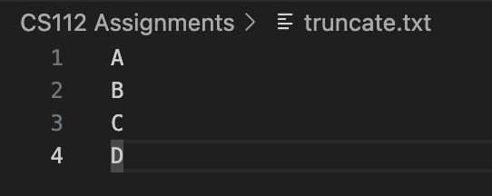

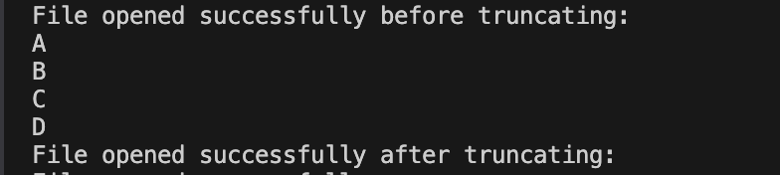

// Task 5

file.open("data.txt", ios::in);

if(!file)

{

cout<<"Error: File not found"<<endl;

}

else

{

cout<<"File opened successfully"<<endl;

file.seekg(10, ios::beg);

cout<<"Reading from position 10: "<<endl;

getline(file, line);

cout<<line<<endl;

}

file.close();

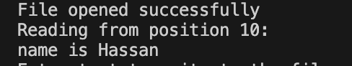



// Task 6

file.open("write_test.txt", ios::out);

if(!file)

{

cout<<"Error: File not found"<<endl;

}

else

{

cout<<"Enter text to write to the file at 5th byte: "<<endl;

getline(cin, line);

file.seekp(5, ios::beg);

file<<line;

}

file.close();



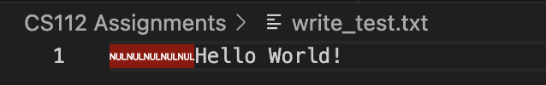

// Task 7

file.open("append_end.txt", ios::app | ios::ate);

if(!file)

{

cout<<"Error: File not found"<<endl;

}

else

{

cout<<"Enter text to write to the end of the file: "<<endl;

getline(cin, line);

file<<"\t"<<line;

}

file.close();



